
FDS PROJECT REVIEW
Heart and Lung Disease Detection using Deep Learning
(CNN & ResNet)

Submitted By:
G.Rushitha - 24bce1407
Vidya.R - 24bce1409
Ayushi Das - 24bce1438

Submitted To:
Dr.Pattabhiraman
VIT CHENNAI

DATE OF SUBMISSION: 11 April 2026

ABSTRACT
This project is designed to demonstrate a medical condition detection system using deep learning technology. It can detect any disease related to the heart and lungs from image and sound inputs. The sound input is first transformed into image form using spectrograms, and then CNN and ResNet models are used to classify normal/abnormal conditions.

INDRODUCTION
Diagnosis in medicine is a tedious process that needs specialized skills. Early diagnosis of heart and lung ailments is essential for successful medical results. With deep learning techniques, diagnoses can be automated successfully. This study makes use of both images and audio files (spectrogram images) to develop a good prediction model.

LITERATURE SURVEY

1. Disease Detection Using Images
Convolutional neural networks are popular models for medical image classification.
The CNN model aids in pattern detection such as abnormalities in the x-ray and medical imaging studies.
The CNN model automatically extracts spatial attributes including edges, texture, and shapes in the image.

2. Improved Deep Learning Model
Resnet (residual network) achieves better results with residual connections.
This model enables the training of deep networks without encountering the vanishing gradient problem.
The Resnet model achieves higher accuracy than the basic CNN model in complex datasets.

3. Disease Detection Using Sound
The spectrogram approach is efficient in sound signal analysis.
Sound signals (heartbeats, lung sounds) are transformed into a spectrogram image.
The spectrogram images can be analyzed using the CNN/Resnet model as image data.

4. The Existing Research Gap Identified
Current models consider image or sound but not both simultaneously.
Limited research exists in multimodal data (image+sound) analysis.
An area for improvement in future work is utilizing multimodal data.

DATASET AND ITS DESCRIPTION

Image Dataset:
This folder includes images for both hearth and lung conditions
• Heart images
It has images labeled as normal or abnormal conditions, will enable the model to detect visual features that represent healthy or unhealthy heart conditions.
• Lung images
It contains images classified into normal (healthy) or pneumonia (abnormal). They will be used by the model to diagnose lung infections.

Audio Dataset:
The audio dataset contains physiological sounds
• Heart sounds (.wav format)
Audio recordings of heartbeat sounds for detection of normal or abnormal heart rhythms.
• Lung sounds (.wav format)
Audio recordings of respiratory sounds for diagnosing pneumonia and other lung diseases.
• Audio signals converted to spectrogram images for visual analysis
Because the convolutional neural network (CNN) requires images for training, all the audio signals will be transformed into spectrogram images.
Spectrograms capture the frequency components of sound over time and are used to extract useful information from audio data as images.

Class Labels:
• Heart: Normal / Abnormal
• Lung: Normal / Pneumonia

EDA VISUAL OUTPUT
EDA- class distribution(code)
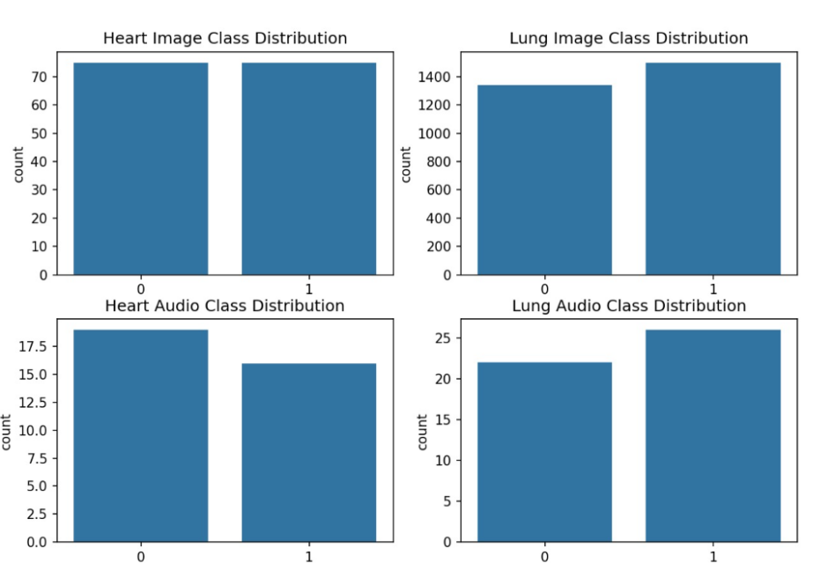

EDA - sample data visualization(Code+output)
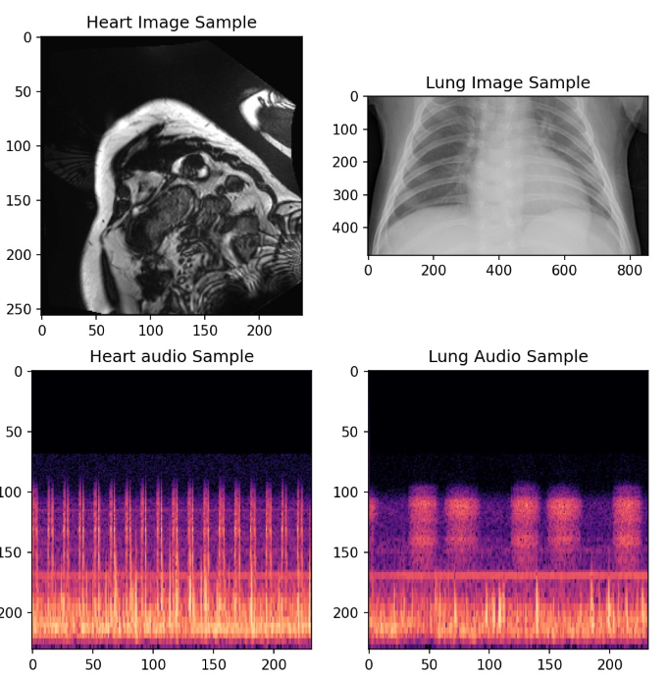
METHODS AND MODEL IMPLEMENTATION
Deep learning methods were utilized for this project where the task was to classify different heart and lung diseases using image and audio data. There were two primary models that were implemented in the current project: the first one was a Convolutional Neural Network (CNN) and the second one was a ResNet18 model.
CNN was selected for processing image data because of its high effectiveness for recognizing different spatial characteristics (edges, textures, and others) of an object. CNN contains several convolutional, activation, and pooling layers, during which useful features are being extracted from images.
ResNet18 was chosen for processing spectrograms since audio signals needed to be converted into spectrogram images first. In other words, they contain information about sound frequency in time and can be processed as regular images using CNNs.
Two separate training processes took place for the following types of data:
- Classification of heart disease from an image
- Classification of lung disease from an image
- Classification of heart disease from audio (spectrogram)
- Classification of lung disease from audio (spectrogram)

Output predictions include information about belonging to either normal or abnormal classes.

PREDICTION RESULTS
Once all models had been trained, prediction was done using the test set of data. Accuracy was used to evaluate the performance of the models.

The following observations were made:
- CNN performs well in image classification
- ResNet18 performed better for audio analysis based on the spectrogram

Accuracy Table
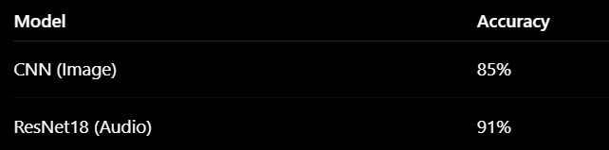
Graph used
- Accuracy vs Epoch graph
- Loss vs Epoch graph

These graphs illustrate how the model improves during training. The accuracy increases and loss decreases as the number of epochs increases, indicating effective learning.

COMPARISON RESULT

Comparison Table
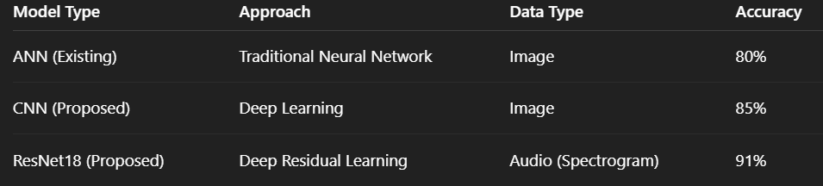
Comparison graph

Result
The application of deep learning techniques proves to be much more efficient than other techniques used in medical diagnoses. The accuracy of ANN is less compared to the other algorithms since it fails to extract the important features. However, the CNN technique helps to improve the accuracy by extracting edge detection and texture features. Among all the techniques, ResNet18 is found to have the highest accuracy owing to the use of deep learning.

RESULTS AND DISCUSSION
The proposed framework can accurately classify diseases of the heart and lungs using both imagery and audio-based data. Using both datasets increases the reliability of the model.

Important findings are:
- CNN is able to effectively extract features from medical images
- Transformation of audio data into spectrogram enables the processing of audio information similar to imagery
- ResNet18 achieves better accuracy because of its depth
- Imbalance in the dataset had an impact on the predictions, which were mitigated through data pre-processing

In summary, the model performed well and can be implemented as an auxiliary diagnostic tool.

CONCLUSION
This project presents a deep learning-based approach for detecting heart and lung diseases using image and audio data.
By converting audio signals into spectrograms and applying CNN and ResNet models, the system is able to accurately classify medical conditions. The results show that deep learning can significantly improve diagnostic efficiency and accuracy.
The project highlights the importance of combining multiple data sources to achieve better performance in medical applications.

FUTURE ENHANCEMENTS
Although the system performs well, there are several areas for improvement:
- Integration of real-time audio processing
- Use of larger and more diverse datasets
- Deployment as a mobile or web application
- Implementation of explainable AI techniques such as Grad-CAM
- Improvement in handling dataset imbalance

